**CN vs AD – X axis (sagittal plane)**



**Approach 1 - 2019_04_20_12_46**

**Network:**

Transfer learning from AlexNet changing last 3 layers.

|  |  |
| --- | --- |
| **Training parameters:**   * folds=3; * miniBatchSize = 32; * learningRate = 1e-5; * maxEpochs=230; * optimizer='sgdm'; * "L2Regularization", 1e-04 | **Dataset:**   * nSlices=6; * gap=2; |

**Results:**

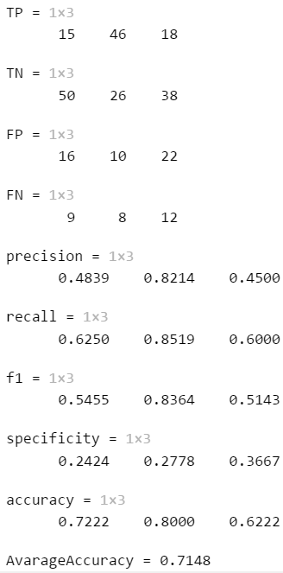

**Approach 2 -**